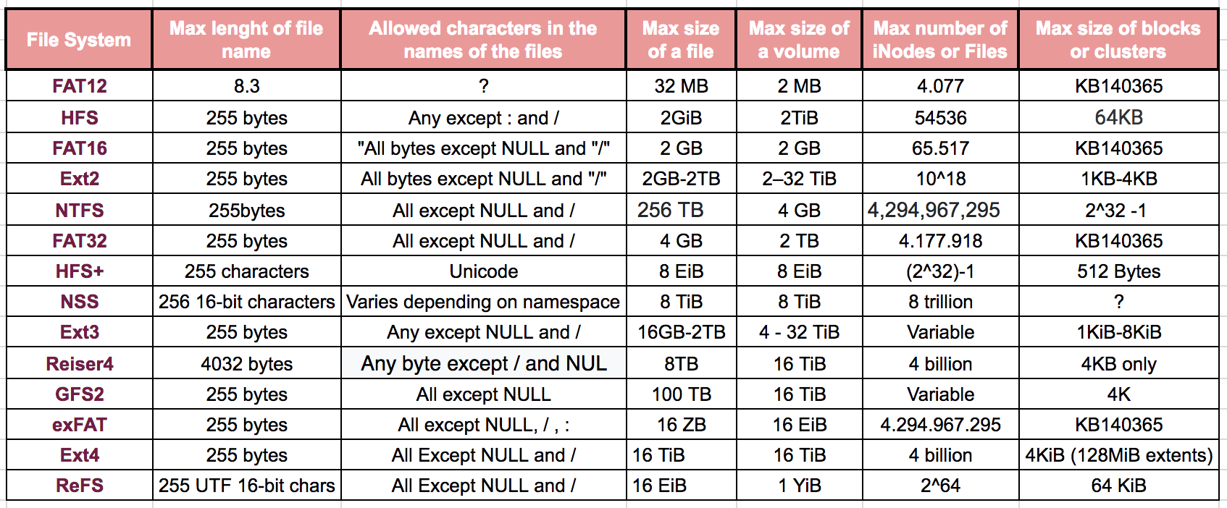

**FILE SYSTEMS**

**System Server Administration**

Notes:

TiB = The tebibyte is a multiple of the unit byte for digital information.

1 tebibyte = 240 bytes = 1099511627776 bytes = 1024 gibibytes

**References**

[https://www.ecured.cu/Tabla_de_asignación_de_archivos](https://www.ecured.cu/Tabla_de_asignaci%C3%B3n_de_archivos)

[http://www.diskinternals.com/glossary/ext2.html](https://www.ecured.cu/Tabla_de_asignaci%C3%B3n_de_archivos)

<https://support.microsoft.com/en-us/help/130437/the-macintosh-hierarchical-file-system-hfs>

<https://technet.microsoft.com/en-us/library/cc938432.aspx>

<http://avid.force.com/pkb/articles/en_US/troubleshooting/en250749>

http://www.golinuxhub.com/2014/05/how-to-configure-gfs2-partition-in-red.html